AskToPromApp: An app with music and image
Created by Kodey Crandall

This step-by-step picture tutorial will guide you through adding music to an app.

To get started, go to App Inventor on the web (will not work with Microsoft Explorer).
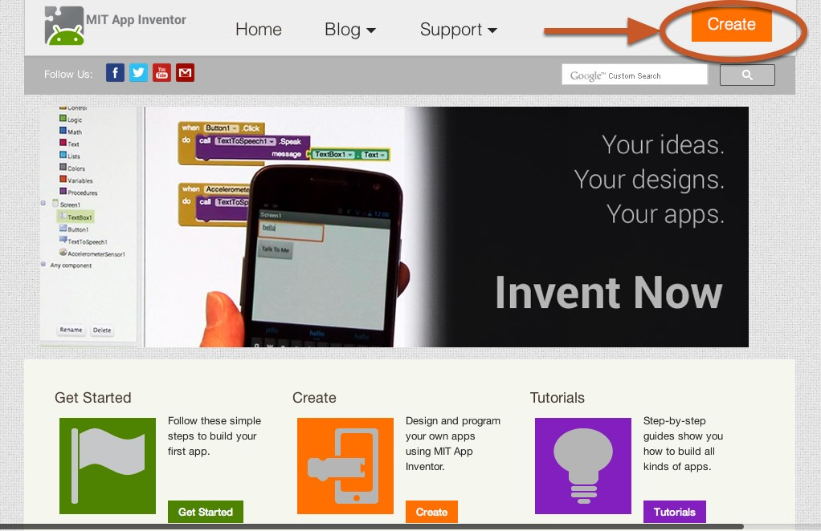
Go directly to ai2.appinventor.mit.edu, or click the orange "Create" button from the App Inventor website.

Log in to App Inventor with a gmail (or google) user name and password.

Start a new project.
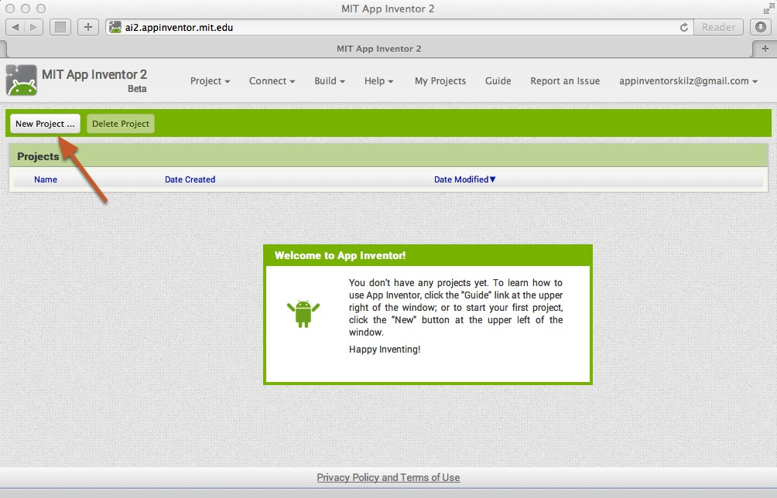

Name the project "AskToPromApp" (no spaces!)
Type in the project name (underscores are allowed, spaces are not) and click OK.

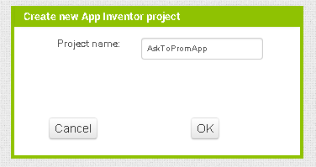

You are now in the Designer, where you layout the “user interface” of your app.
This app requires an image and button to play the music and the media player. Let’s begin with the image by dragging the “Image” control to the Viewer. Next we need to add the audio file from the website kodeycrandall.com. FYI, App Inventor’s max size is 5MB.

Add an image
Our project needs an image. Click and hold on the word "Image" in the palette. Drag your mouse over to the Viewer. Drop the image and a new image icon will appear on the Viewer.

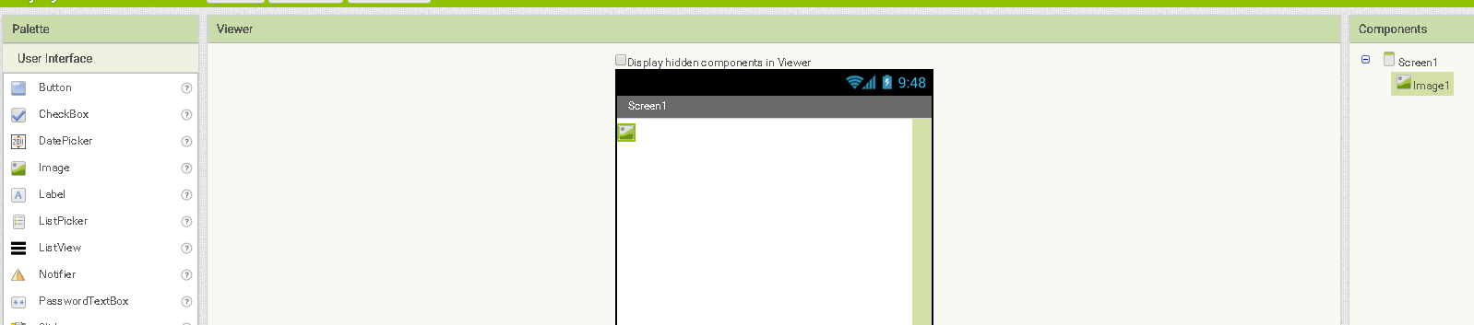

Connect App Inventor to your phone for live testing
Connect to the on-screen emulator or to your android device. If you are not sure how this is done, refer to tutorial 1 TalkToMePart1.
Select the menu Connect at the top of the screen and select Emulator or AI Companion.
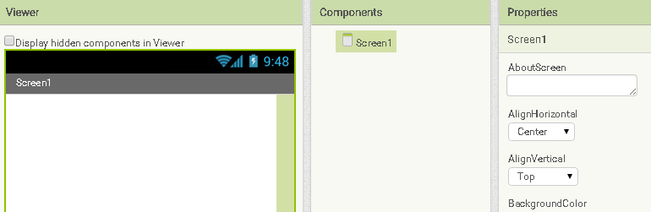

Align Horizontal for Screen1
To center the controls, you will need to align the content horizontally. To do this, click on the white space in the viewr and set the AlignHorizontal to “Center”.

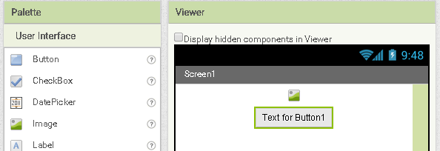

Add a play button and change the image property
Click and drag a button from the Palette under the image icon added from the previous step. Next set the image property to a play image. (You can download the icon from http://kodeycrandall.com/app-inventor.html ).
You will first want to delete the text out from behind the image. Next, because the image is quite large, you might want to change the Width and Height to 75 pixels. To change the Width and Height of the button click on the button and at the bottom of the “Properties”, click on Width and type 75 for pixels, then do the same for Height.
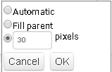

Add names for the button
Each control you add should have a name that you will refer to in the blocks. To rename the play button, go to the Components area, click on Button1, then click the “Rename” below (Example: Button1 should be renamed to something like – btnPlay).

Add a Player Media component to your app
Adding a song to an app requires three steps in the Designer.
- Select the Media drawer and drag the Player onto the Viewer. (It is a hidden component so it will appear at the bottom of the viewer.
- Upload the song to the app.
- Attach the song to the Player
Go to the Media drawer and drag out a Player component. Drop it onto the Viewer. Notice that it drops down under "Non-visible components" because it is not something that will show up on the app's user interface. It's more like a tool that is available to the app.
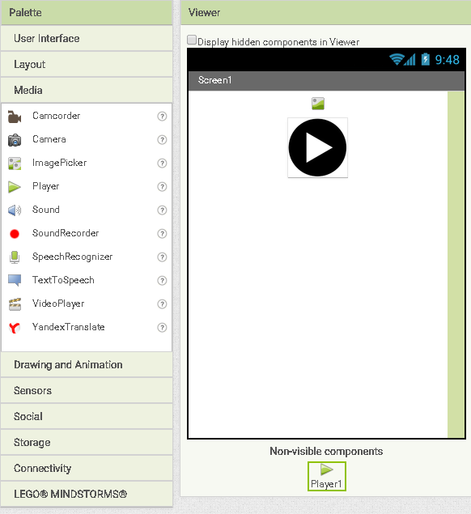

Add an picture to the image
Let’s set the image! Click on the Image1 icon and from the properties, click “None…” under Picture. To add an image, click upload file and search for the image you want (We will be using the images from kodeycrandall.com).
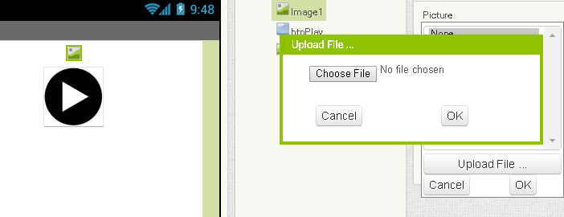
Let’s Start BUILDING!!
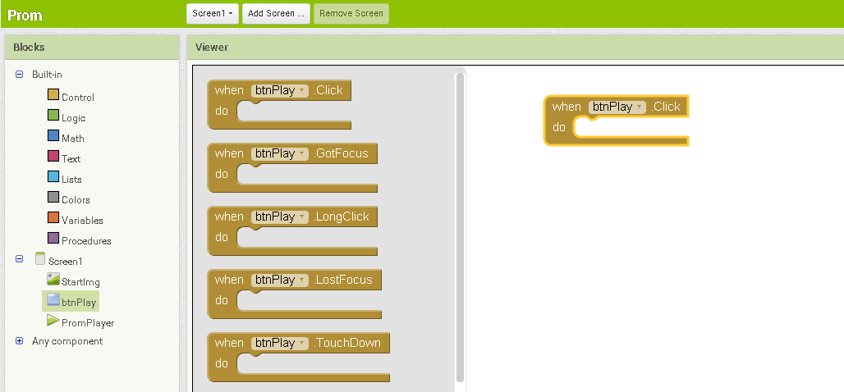

Switch over to the Blocks Editor
It's time to tell your app what to do! Click "Blocks" to move over to the Blocks Editor. Think of the Designer and Blocks buttons like tabs -- you use them to move back and forth between the two areas of App Inventor.
Next you will need to drag a Screen1.Initialize screen block to the Viewer. We will need to SET the music before the app is visible. You will also need to click the btnPlay button on the left and drag a Click block in the Viewer as well as a Player1.Completed block.
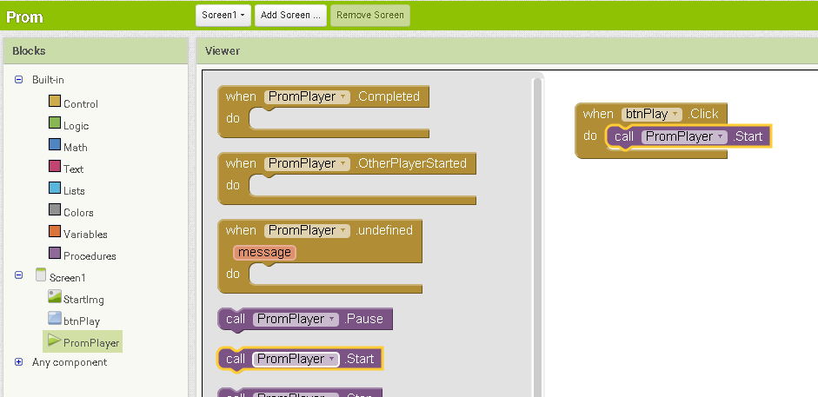

The Player will allow you to start, stop, and play the music.
Find the player on the left side and click on it. We first need to set the song before the app is visible. To add the song click Player1 to the left and click and drag the “call PromPlayer.Start” block in the when btnPlay.Click block.
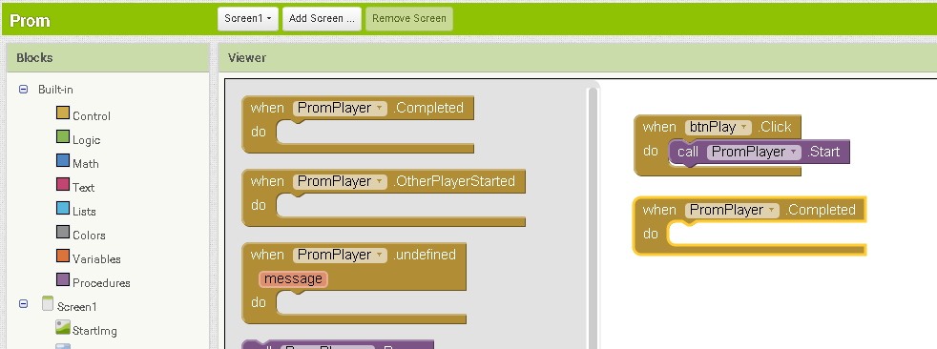

Play the song
When the person clicks the play button, we want the music to start playing. To start the player, click Player1 to the left and drag a purple block “call Player1.Start” block in the “when btnPlay.Click” block.

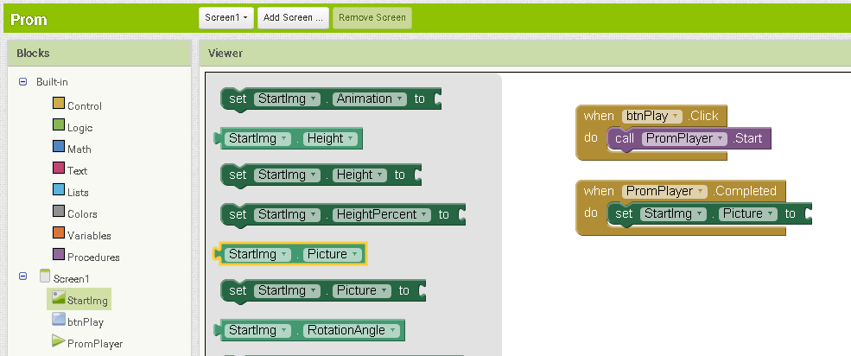

Save app space with HTML references
Because the app can only hold 5MB of space, you are limited to a certain point. To save space you can link content from online (Remember, the user will need internet access).
Drag a blank pink text block on the end of the “set StartImg.Picture to” and type “AskImg.jpg” as show below
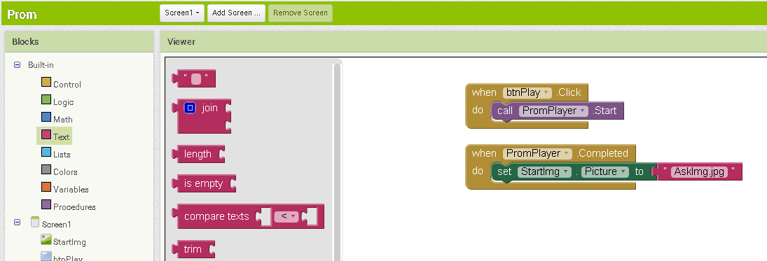

Change the image after song completes
Once the Player has played the complete song, you can have your app do something. Let say a student wants to ask a girl to the prom in a creative way. He can share this app with the girl he would like to ask, and as soon as the song is over, the image will change to a “Will you go to prom with me…” image. To do this we need to change the image when the song is done. Drag a “set StartImg.Picture to” block in the “PromPlayer.Completed” block. Lastly, you will need to drag a pick “blank” text block to the right of “set StartImg.Picture to” and type in the name of the image you imported.

Test your cool new app!

Ideas similar to AskToPromApp
Tutorial Music and Picture: I Can Make Money Building Apps!!!
Selling personal apps to make money for your club is a great way to get students motivated to be entrepreneurial and keep engaged. This app could
- Play your favorite audio file and display your favorite picture
- Display a motivational image and play a motivational audio file
- The key is each app is to make it personal to the client. Of course to use, the client must be using an Android device.

