Schedule for App Inventor Workshop
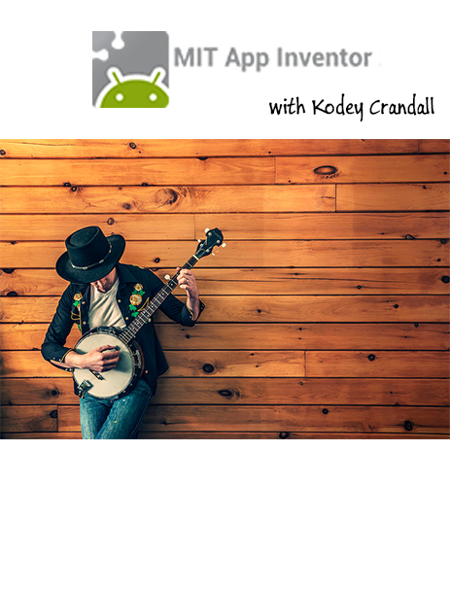
Introduction to App Inventor
Resources—Tutorials, Instructions on setting up a classroom, teacher resources, sample apps, and more.
Tutorials can be printed but videos are available.
Designer and Blocks Editor
Not Compatible with Microsoft Explorer
Tutorial TalkToMe Text-to-speech app (part 1)
Tutorial 2 Don’tShakeMe added to the TalkToMe app
Tutorial Play Audio File
Package app
Explore Teacher Resources
Tutorial 3 or 4
Explore other apps and tutorials
Questions

Resources
http://kodeycrandall.weebly.com/
http://freemusicarchive.org/curator/video
https://www.flickr.com/photos/free_for_commercial_use/sets/72157645035588435/

App Inventor 2
URL: ai2.appinventor.mit.edu or appinventor.mit.edu/explore/

CANNOT BE USED ON Microsoft Explorer

App Inventor is a cloud-based tool, which means that you can build apps right in your web browser. This website offers all of the support that you'll need as you learn how to build your own apps. The App Inventor software, or "service" is all on the web. AND—that same computer can display the emulator, live testing (how the app will work and act) or you can use an Android device.

Three starter apps: Talk to Me Part 1, Talk to Me Part 2, Ball Bounce, and Digital Doodle are tutorials available as handouts and as a video. These beginner tutorials will teach students the basics of programming apps for Android.

App Inventor is free. Teachers get support and tips for using App Inventor.

If YouTube is blocked, see the videos on Vimeo instead of YouTube.

Features that make MIT App Inventor a good learning investment for students includes the variety of programing skills available. The logic of events and actions are typical skills for any programming class.
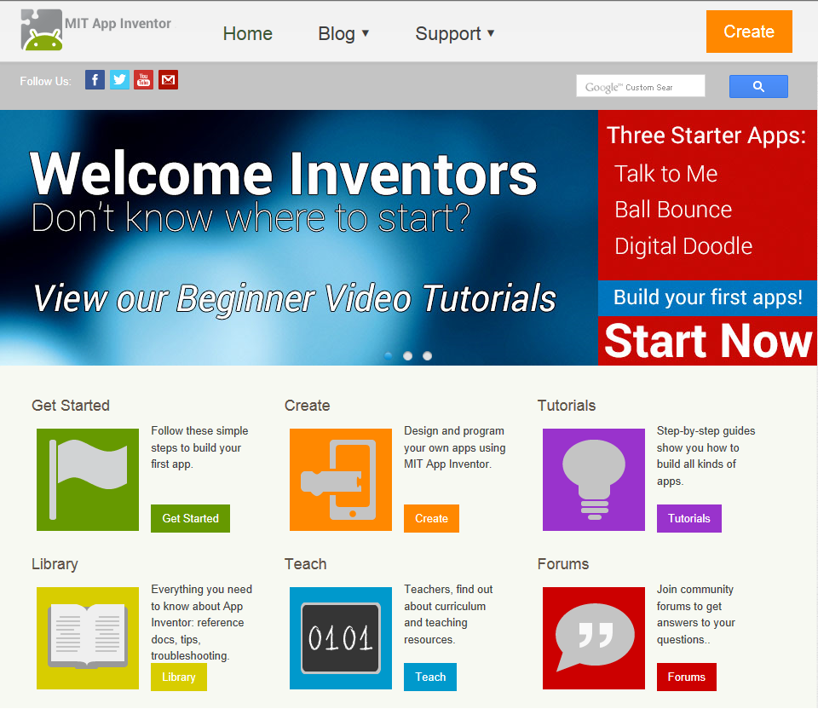
Samples of the variety of events that App Inventor includes are:
Video Games Camera
Multiple Screen SMS Texting Location Sensor
GPS Clocks and Timers Drawing Canvas
Data Storage Accelerometer

I Can Make Money Building Apps!!! Let your club write individual apps to raise money.
Selling personal apps to make money for your club is a great way to get students motivated to be entrepreneurial and keep engaged. This app could
- Play your favorite audio file and display your favorite picture
- Invite someone to the Prom
- Display a motivational image and play a motivational audio file
- The key is each app is personal to the client. Of course to use the app, the client must be using an Android device.
The resources from MIT App Inventor are easy to use and include many different projects. I especially like the great step-by-step instructions plus some tutorials include videos.
Samples of MIT App Inventor tutorials include:
Magic 8-ball Mini Golf Where’s My Car
MoleMash Space Invaders Map It
PaintPot Pizza Party with Fusion Tables StockQuotes

Youtube has a number of very good App Inventor tutorials—just make sure you are watching App Inventor 2 tutorials. I especially like the David Wolber tutorials. He has written over 40 tutorials but all of them are not App Inventor 2 videos.
Examples of apps written include:
Parents can track their kids on bus rides home from school. Created by students K-8
Reading Log for Kids, written by high school students
Learn by State-Idaho, app with quizzes and map information about Idaho, written by high school student
App to determine which foods during lunch could impact students with allergies
Time magazine featured an article about middle school students who created an app to encourage more recycling in their community.
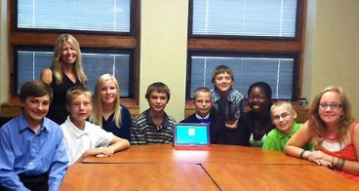
Students Featured in TIME For Kids created an app to encourage more recycling in their community.

